Network Devices
What is a computer network?
Is a digital telecommunication network which allows nodes to share recourses.
What is client?
Client is a device that accesses a service made available by a server.
What is server?
Is a device that provides functions or services for clients.
The same device can be a client in some situations, and a server in other situations.
What are a switches?
A network switch acts as a central hub connecting computers, printers and servers within a local area network (LAN).
Switches are used to for a traffic within a LAN (Local Area Network).
Pc1 and Pc2 that are located in New York can send data to each other with a switch however, the switches cannot connect to the internet directly and send data to the servers in Tokyo.
Characteristics of switches
- Have many network interfaces/ports for end hosts such as PCs to connect to usually 24 or more.
- Provides connectivity to hosts within the same LAN (Local Area Network).
- Do not provide connectivity between LANs or over the internet. To do so we need another kind of network device and that device is router.
We can connect the switches to the routers, and then connect the routers to the internet.
When end hosts in the New York branch LAN, wants to communicate with end hosts in the Tokyo branch LAN they will send the data to their router in New York branch which will forward it to the Tokyo branch LAN via the internet. For example:
If the PC1 in the New York branch wants a file on server1 on Tokyo branch, it will send a request to the router1 which is in New York via switch1 which will forward it over the internet to router2 in Tokyo which will send it to server one via switch2 the replay then follow the reversed path from server1 to switch2 to router2 over the internet, and then router1 then switch1 and then lastly PC1.
Characteristics of routers
- Routers have fewer network interfaces than a switches
- Routers are used to provide connectivity between LAN’s and switches within LAN’s
- Routers are therefore used to send data over the internet
Firewalls
Firewalls are specialty network security devices that control network traffic entering and exiting your network. Firewalls can be places outside of your router or inside of your network.
The importance of a firewall is that they protect the end hosts inside, like the PC’s and servers in the network.
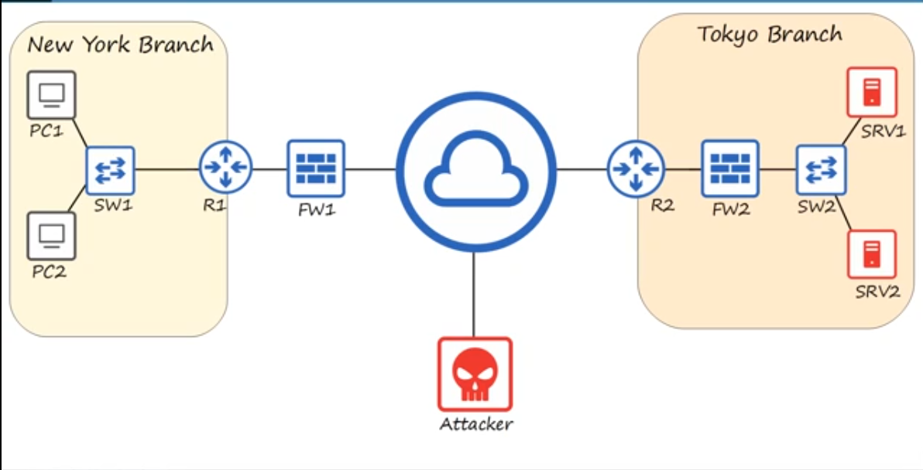
Characteristics of Firewalls
- Firewalls monitor and control network traffic based on configured rules
- Firewalls can be placed “inside” the network or “Outside” the network
- Firewalls are known as “Next-Generation Firewalls” when they include more modern and advanced filtering capabilities.
Network firewalls
Are hardware devices that filer traffic between networks.
Host-Based firewalls
Are software applications that filer traffic entering and exiting a host machine, like a PC.

Questions
- Your company want to purchase some network hardware to which they can plug the 30 PCs in your department. Which type of network device is appropriate?
- A router
- A firewall
- A switch
- A server
- The answer is C: a switch
- You received a video file from your friend’s apple iPhone using Airdrop. What was his iPhone functioning as in that transaction?
- A server
- A client
- A local Area Network (LAN)
- The answer is A: a server
- What is your computer or smartphone functioning as while you watch this video?
- A server
- An end host
- A client
- The answer is C: a client
- Your company wants to purchase some network hardware to connect its separate networks together. What kind of network device is appropriate?
- A firewall
- A host
- A LAN
- A router
- The answer is D: a router
- Your company wants to upgrade its old network firewall that has been in use for several years to one that provides more advanced functions. What kind of firewall should they purchase.
- A host-based firewall
- A next-level firewall
- A next-generation firewall
- A top-layer firewall
- The answer is C: a next-generation firewall
Interfaces and Cables
What is Ethernet?
Ethernet is a collection of network protocols/standards.
Why do we need network protocols/standards?
If two people are talking to each other, and one only speaks English and the other speaks Japanese there is not going to be much or any communication between them. What they need is some agreed upon system of communicating like a common language between them. Network protocols serve that purpose for network devices.
Bits and Bytes
Connections between devices and a network, operate at a set speed, these speeds are measured in bits per seconds.
What is a bit?
If a value represented by either a 0 or 1, this binary code is how computers work and operate.
When communicating across a copper network cable, a variation in the electrical signal is interpreted by the receiving device as a 0 or 1.
What is a byte?
8 bits = 1 byte. Speed is measured by bits per second
1 kilobit = 1000 bits
1 megabit = 1,000,000 bits
1 gigabit = 1,000,000,000 bits
1 terabit = 1,000,000,000,000 bits
Ethernet Standard
Defined in IEEE 902.3 standard in 1983
IEEE = institute of electrical and electronic engineers
Speed | Common Names | IEEE Standard | Informal Name | Maximum Length
10 Mbps | Ethernet | 802.3i | 10BASE-T | 100 M
100 Mbps | Fast Ethernet | 802.3u | 100BASE-T | 100 M
1 Gbps | Gigabit Ethernet | 802.3ab | 1000BASE-T | 100 M
10 Gbps | 10 Gig Ethernet | 802.3an | 10GBASE-T | 100 M
BASE = refers to Baseband Signaling
T = Twisted Pair Cabling

UTP Cables
The copper cables used in ethernet standards are UTP Cables. UTP stands for (Unshielded Twisted Pair).
10BASE-T and 100BASE-T use 2 pairs (4 wires)
1000BASE-T and 10GBASE-T use 4 pairs (8 wires)
How the cables work for 10BASE-T and 100BASE-T
There are 8 but we are going to use just 4 or two pairs since this is a fast ethernet or 100BASE-T connection.
The first pair at the pin position of 1 and 2 and we will connect those on the switches interface.
The PC will use pin’s 1 and 2 to transmit data to the switch, since the PC is transmitting data over 1 and 2 the switch cannot transmit data to the PC over the pin’s 1 and 2, it has to receive data on pin’s 1 and 2.
The next pair that is used in a 10BASE-T and 100BASE-T cable is not 3 and 4, it is 3 and 6 and the function of each pin is opposite of the pairs of 1 and 2. On the switch pin’s 3 and 6 are used to transmit data, and on the PC pin’s 3 and 6 are used to receive data. This allows for something called full duplex transmission which means that both devices send and receive data at the same time.
Now if we changed the PC device to a router just as PC connects to a switch, a switch usually connects to a router. So, pin’s 1 and 2 receive data and pin’s 3 and 6 transmit data from router to the switch and from switch to router.
What if we wanted to connect two routers or two PC’s or two switches? We simply can’t use pin 1 and 2 to receive data and pin 3 and 6 to send data that simply doesn’t work. To solve this problem, we are going to use a method called Crossover Cable. This method crosses the cables so it can receive and send data effectively. To do the Crossover Cable method we are simply going to connect pin 1 to pin 3 and pin 2 to pin 6, and then connect pin 3 to pin 1 and pin 6 to pin 2, this allows the two switches, PC’s and routers to send and receive data.
The network card on the PC and the network interfaces on a router both transmit data on pin’s 1 and 2 and receive data on pin’s 3 and 6, however if you connect them with the crossover cabling method, they will be able to exchange data with no issues.
Here a chart reviewing different device types and the pin’s they use to transmit and receive data.

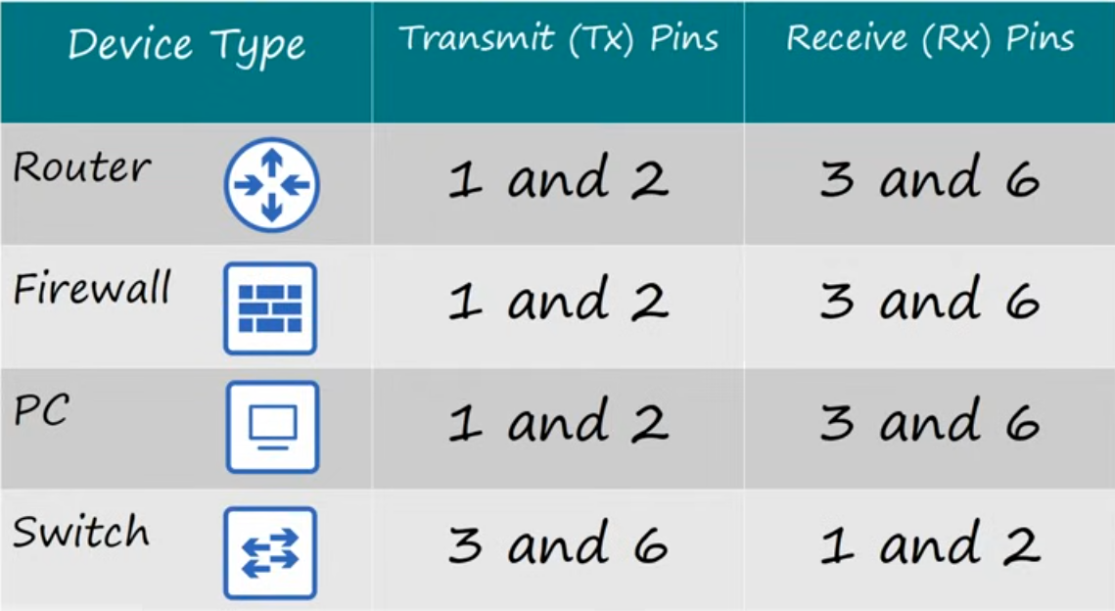
Now in modern networking we don’t have to worry about cabling because we got something called Auto MDI-X which allows cables to detect their neighboring cable on which cables are they receiving/sending data and that allows them to switch so they can fit and send/receive data effectively without using straight through or crossover cabling, unless you are working with old network cabling you don’t have to worry about this.
How cables work for 1000BASE-T and 10GBASE-T
For gigabit ethernet and 10 gigabit ethernet all eight wires are used. And the last two pairs are 4 and 5, 7 and 8.
The difference between 1000BASE-T, 10GBASE-T and 10BASE-T, 100BASE-T in addition to using all 4 pairs of wires in 1000BASE-T and 10GBASE-T each pair is bidirectional meaning each pair isn’t dedicated to receiving data or transmitting data, this is part of the reason that they can operate at much faster speed.
Fiber-Optic Connection
The copper UTP cable use separate wires within the cable to transmit and receive data but the fiber-optic use separate cables to transmit and receive data.
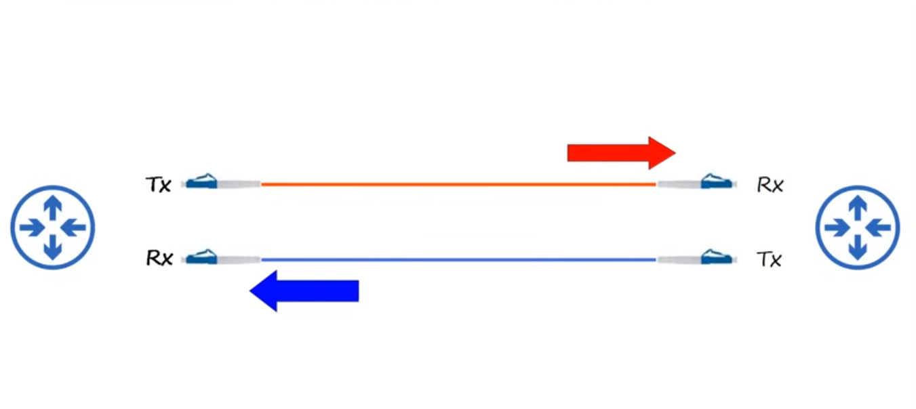
The transmit on the left connects to receive on the right. And receive on the left connects to transmit on the right.
Let’s examine the structure of the cable itself.
There are 4 numbered parts in the diagram at the bottom, from the center to the outer layer.
- The fiberglass core itself – light is transmitted down this core to transmit data from one device to another.
- Cladding that reflects light.
- A protective buffer – which protects the fiberglass from breaking.
- The outer jacket of the cable
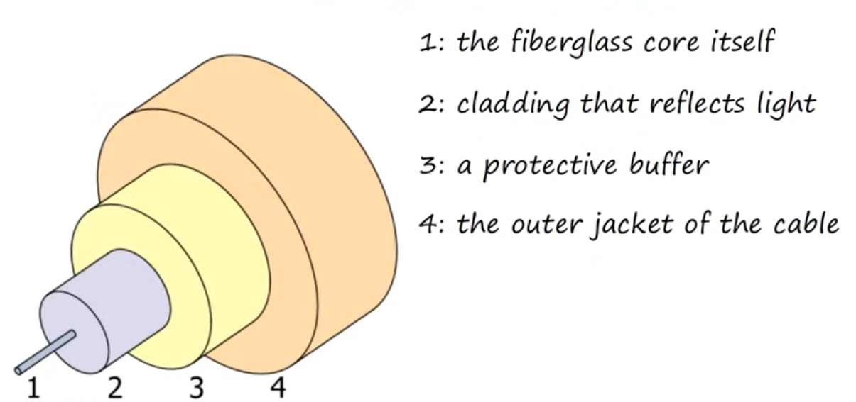
There are couple main types of fiber-optic cables: -
- Single-mode fiber
- Multimode fiber
Characteristics of Multimode Fiber
- Core diameter is wider than single-mode fiber
- This wider core allows multiple angles (modes) of light waves to enter the fiberglass core.
- Allows longer cables than UTP which are limited to 100 meters, but still shorter cables than single-mode fiber.
- Cheaper than single-mode fiber (due to cheaper LED-based SFP transmitters).

Characteristics of Single-Mode Fiber
- The core diameter of a single-mode fiber is narrower than multimode fiber, meaning the glass fiber is thinner.
- Light enters at a single angle (mode) from a laser-based transmitter.
- Single-mode fiber allows longer cables than both UTP and Multimode fiber.
- Single-mode fiber are more expensive than multimode fiber (due to more expensive laser-based SFP transmitters).
Fiber-Optic Cable Standards
Informal Name | IEEE Standard | Speed | Cable Type | Maximum Length
1000BASE-LX | 802.3Z | 1 Gbps | Multimode or single-mode | 550 Meter (Multimode Fiber)  5 km (Single-mode fiber)
10GBASE-SR | 802.3ae | 10 Gbps | Multimode | 400 Meter
10GBASE-LR | 802.3ae | 10 Gbps | Single-mode | 10 km
10GBASE-ER | 802.3ae | 10 Gbps | Single-mode | 30 km

Comparing UTP vs Fiber-Optic Cabling
UTP | Fiber-Optic
- Copper UTP Cables are much cheaper than fiber-optic cables.  - Maximum cables distance for UTP cables are shorter than fiber-optic cables about 100 meters maximum.  - Can be vulnerable to EMI (Electromagnetic Interference) although the twist in the cable pair helps protect against this.  - The RJ45 ports to which UTP Cables connect are cheaper than the SFP’s ports used for fiber-optic connections.  - UTP Cables emit (leak) a faint signal outside of the cables which can be possibly be detected and used to copy data posing a possible security risk. | - Fiber-Optic Cables are more expensive than UTP Cables.  - They support longer distances than UTP cables.  - Their SFP ports are much expensive than RJ45 ports and single-mode fiber ports are more expensive than multimode  - No Vulnerability to EMI (Electromagnetic Interference).  - The did not emit (leak) any signal outside of the cable so there is no security risk there.

Questions
- You connect two old routers together with a UTP cable; however, data is not successfully send and received between them. What could be the problem?
- They are connected with a straight-through cable.
- They are connected with crossover cable.
- They are operating in Auto MDI-X mode
- The answer is A: They are connected with a straight-through cable.
- Your company want to connect switches in two separate buildings that are about 150 meters apart. They want to keep costs down, if possible. What kind of cable should they use?
- UTP
- Single-mode fiber
- Multimode fiber
- The answer is C: Multimode fiber
- Your company want to connect two offices that about 3 kilometers apart. They want to keep costs down if possible. Which kind of cables should they use?
- UTP
- Single-mode fiber
- Multimode fiber
- The answer is B: Single-mode fiber
- A switch has the following indication over its network interfaces; 10/100/100Base-T ports(1 – 24) ports – Ports are Auto-MDIX. What would happen if you connect it to an identical switch with a straight-through cable?
- They would operate normally
- They would operate at a reduced speed
- They would be unable to connect
- The answer is a: They would operate normally
- Your company needs to connect many end hosts to a switch which is in a wiring cabinet on the same office floor as the hosts. What kind of cable should they use?
- UTP
- Single-mode fiber
- Multimode fiber
- The answer is a: UTP
- Why? UTP cables are the standard for wired connections to switches. Switches typically have many RJ45 ports for end hosts to connect to, and end hosts will have an RJ45 port on their network interface card (NIC) to connect a UTP cable to.

TCP and IP
TCP stands for (Transmission Control Program).
IP stands for (Internet Protocol).
Protocols and Standard definition
Protocol: is a set of rules defining how data should be communicated between devices over a network.
Protocols are the language computers use to communicate.
Standard: is an agreed-upon specification that describes how a protocol or technology should work.
When devices follow vendor-neutral standards devices of all types can communicate with each other.
How does TCP and IP work
There are 5 layers that they must follow in order to work and they are: -
- Physical Layer – Sends bits as electrical, optical, or radio signals over the physical medium.
- Local Network Layer – Provides hop-to-hop delivery within a local network using MAC Addresses and switches.
- Internet Layer – Provides end-to-end communication between hosts across network using IP addresses and routers.
- Transport layer – Provides end-to-end communication between application processes using Port Numbers.
- Application layer – Protocols for communication between application processes; create and interpret the data.
Imagine this 5 layers as a mail delivery system, you want to send a message to Kendrick and the message contains content, you drive from your home to post office A and post office A takes your message puts it in a truck and delivers it to Kendrick’s home and then Kendrick takes your message and reads it. That is exactly how TCP/IP works.
Each layer has it is own job. Layers work together to deliver the message, but each one focuses on it is own task.
What happens inside one layer doesn’t change the job of the other layers.
Changing the content of the letter doesn’t change the delivery steps.
Changing the delivery path doesn’t affect the letter itself.
Content layer: The text of the letter, what you actually want to say. | Application Layer
Recipient layer: “To:Kendrick” vs “To:Kendricks’s Wife”: The intended recipient inside the house. | Transport Layer
Address layer: The intended destination address for the house where the recipient lives. | Internet Layer
Local delivery layer: delivery to the next stop on the path using cars/trucks: post office A, then post office B, then Kendricks’s house. | Local Network Layer
Infrastructure Layer: The roads that carry the cars and trucks. | Physical Layer

Layer 1: The Physical Layer
The physical layer (also called; layer 1) sends and receives bits as electrical, optical or radio signals over the medium.
Defines things like cables, connectors, signal levels and link speeds.
Examples: copper UTP cables, fiber-optic cables, WIFI radios and antennas, network interface cards (NICs).
The physical aspects of transmitting data are very complex involving a lot of electrical or optical engineering. Fortunately, network engineers typically don’t have to know the low-level details of how it all works.
Picture of the Physical layer.
UTP ports and the cable on the left, fiber-optic in the middle and NIC on the right.
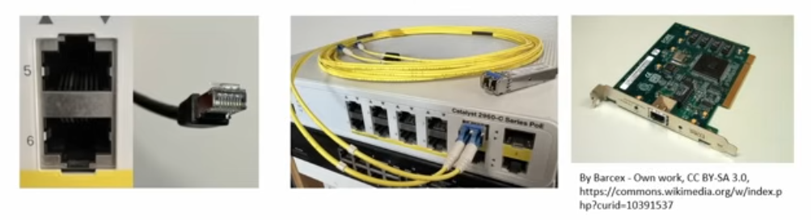

Layer 2: The local Network Layer
This layer provides hop-to-hop delivery of messages on a local network
What is a hop?
A hop is one step along the path between two devices. From one router or host to the next router or host in the path.
Switches don’t count: a switch just extends the local network, allowing multiple devices to connect.
Layer 2 uses MAC (Media Access Control) addresses to identify interfaces. Each devices connected to a LAN has unique MAC address for that specific interface.
Protocols at this layer include:
- Ethernet (IEEE 802.3)
- WIFI (IEEE 802.11)
Layer 3: Internet Layer
This layer provides end-to-end deliver between hosts across multiple networks.
Internet means = internetwork (Between Networks)
It uses IP addresses to identify hosts in the network. Let’s say server one has the IP address of 10.1.1.1, so when PC1 sends a message to server 1, it addresses the message to server 1’s IP address.
Routers mainly operate at this layer, using the message’s destination IP address to forward the message toward its final destination host.
Protocols at this layer include:
- IP (IPv4, IPv6)
- ICMP (Internet Control message Protocol)
Layer 4: The Transport layer
This layer provides end-to-end communication between applications processes.
Why is this needed?
Our server 1 provides multiple services it is running a web server and a file server and perhaps other services. If server 1 receives a message it needs a way to know which of these services should receive the message. This can also be called (Process to Process) or (Service to Service) communication.
This layer uses port numbers to identify the processes on each host. Such as port 80 for web server and port 21 for file server. So, when the web client o PC 1 wants to send a request to the web server running on server 1, it addresses the message to port 80. And if PC 1 want to access the file server instead, it will address its message to port 21.
The transport layer allows the host to differentiate between these different streams of data.
Layer 4 runs mainly on the communication hosts to PC 1 and Server; routers normally operate based on IP (layer 3), not on transport-layer information.
Protocols at this layer include:
- UDP (User Datagram Protocol): Simple and efficient
- TCP (transmission Control Protocol): More robust features beyond basic message addressing.
Layer 5: The application layer
The application layer (Layer 5) is where networks communications meet applications.
The application layer defines how application processes format, send, and interpret data.
Protocols at this layer define message formats and rules for specific tasks, such as: -
- Browsing web pages (HTTP/HTTPS)
- For file transferring (FTP, TFTP)
- And sending/receiving emails (SMTP, POP3, IMAP)
Network infrastructure devices (router, switches) don’t care about application-layer details, they just move message across the network because it is too high level for them. Only the communicating hosts PC1 and Server 1 actually look at and interpret the application-layer data.
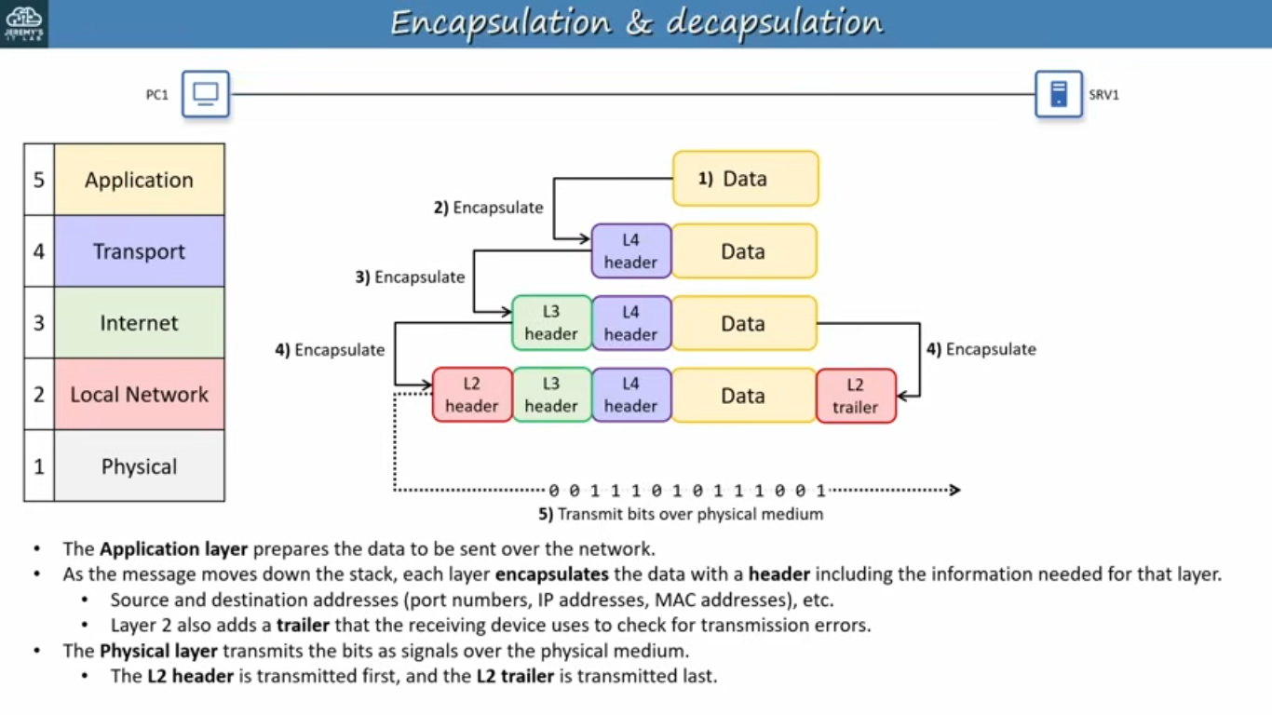
Decapsulation Process
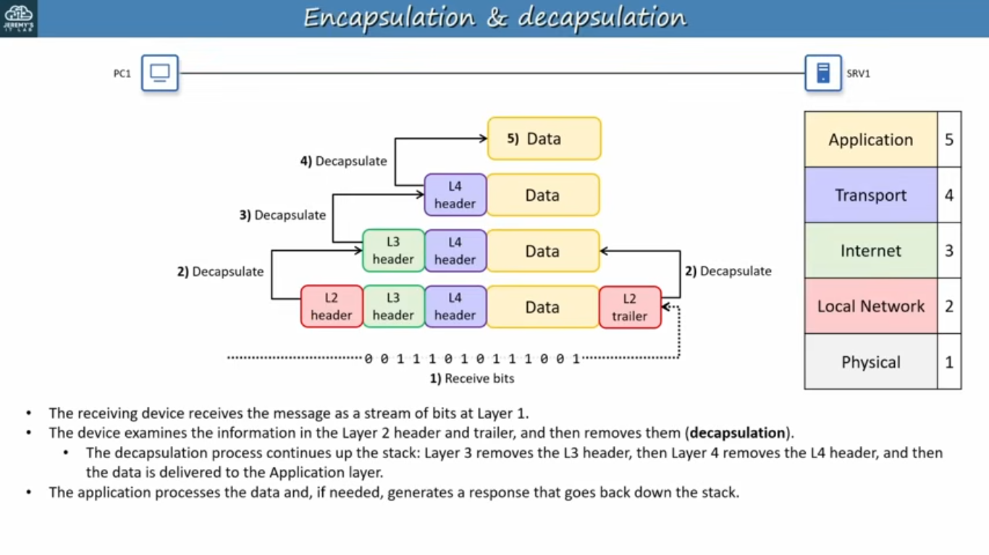
Protocol Data Units
At each stage at in the encapsulation and decapsulation process, there is a name given to the message. The combination of data in layer 4 header is called a segment when using (TCP) or datagram when using (UDP).
Note: TCP creates Segments and UDP creates Datagrams.
The combination of a segment/datagram and a layer 3 header is called Packet.
The combination of a packet and layer 2 header/trailer is called Frame. This is actually what is sent over the wire.
We can use alternative names to describe the message at each stage: Protocol data unit (PDU). A segment or datagram is a Layer 4 PDU (L4PDU).
A packet is a Layer 3 PDU (L3PDU).
And a frame is a Layer 2 PDU (L2PDU).
The contents of each PDU (Everything encapsulated by that layer’s header/trailer) are called the Payload. A segment or datagram’s payload is the application data itself.
A packet’s payload is a segment or datagram.
A frame’s payload is a packet.
How do they interact with each other
Each layer provides a service to the layer above it, and is serviced by the layer below it and it is called (adjacent-layer interaction). For example, layer 4 provides a service to layer 5 by delivering data to the correct application using ports.
Layer 3 provides a service to layer 4 by delivering segments/datagrams to the correct destination host using IP addresses.
Layer 2 provides a service to layer 3 by delivering packets to the next hop using MAC addresses.
Layer 1 provides service to layer 2 by sending and receiving frame as electrical, optical or radio signals. Each layer relies on the layer below it to do it is job.

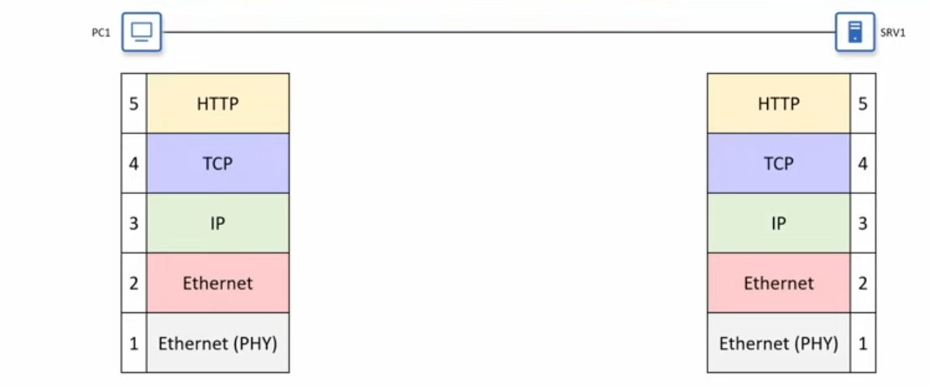
There is also a related concept each layer communicates with the same layer on the other device and it is called (same-layer interaction). For example:
The application layer on one host sends data to the application layer on the other host.
A segment/datagram is addressed to the Layer 4 port number of the correct application on the destination host.
A packet is addressed to the layer 3 IP address of the destination host.
A frame is addressed to the Layer 2 MAC address of the next hop
And signals sent out of a physical port are received by a physical port on the connected device.
This layer cooperation within each device and between devices is what makes network communication possible.

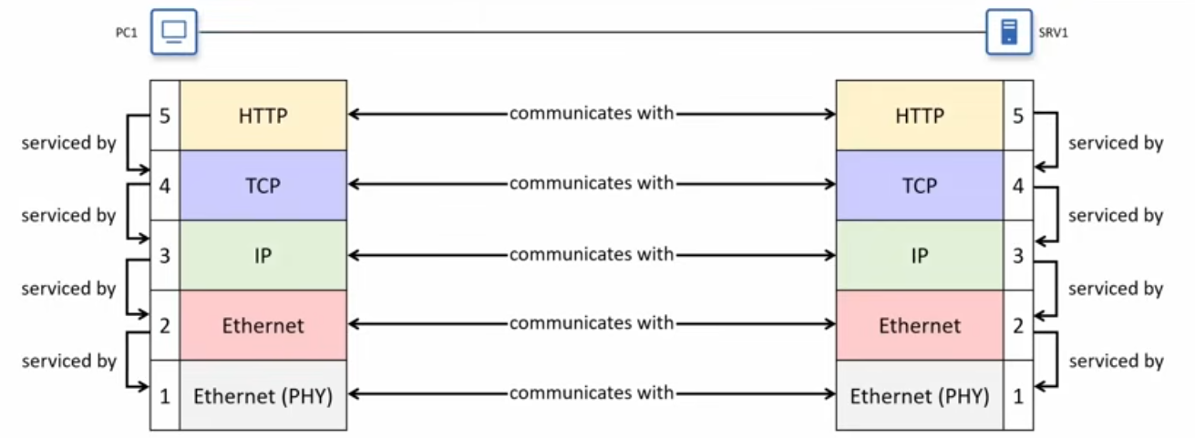

The OSI Model
TCP/IP development started in the late 1970s (ARPANET work, early TCP/IP specs)
In the late 1970s and 1980s, the International Organization for standardization (ISO) designed a 7-layer Open Systems Interconnection (OSI) Model and matching protocol suite. The goal was to create international, vendor neutral networking standards that could unify existing propriety stacks and potentially replace TCP/IP.
Governments, including the U.S, promoted OSI as the preferred/recommended stacks for new deployments. OSI protocols ended up being late and complex, and never gained the same deployment as TCP/IP. Today, almost all real networks use TCP/IP, but the 7-layer OSI model survives as a reference/teaching model and a common way to talk about “Layers”
Most networking resources use a 5-layer model like the one covered above, but with names from the OSI model. That is why the TCP/IP application layer is often called Layer 7.
 | Adapted 5-layer model |  | OSI model
7 | Application | 7 | Application
4 | Transport | 6 | Presentation
3 | Network | 5 | Session
2 | Data link | 4 | Transport
1 | Physical | 3 | Network
 |  | 2 | Data Link
 |  | 1 | Physical

Introduction to CLI
What is CLI?
CLI stands for Command-Line Interface. It is the interface you use to configure cisco devices like; routers, switches and firewalls.
User EXEC mode: Is limited and can’t do much with it.
Privileged EXEC mode: is a full access let’s change and edit information.
You can identify if it is user or privileged mode, for user you will see the greater than sign ( > ) indicating that you are on the user EXEC mode.
For the privileged mode, you will see the hash sign ( # ) indicating you are on the privileged EXEC Mode.
You the question mark ( ? ) to view the available commands.
Commands for both User and privileged EXEC Mode:
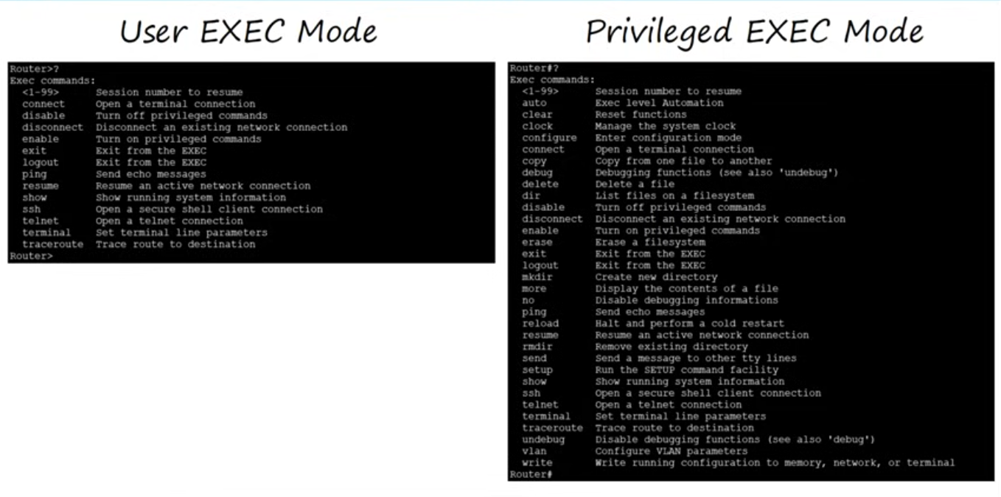
To enable the privileged EXEC mode, you type (en or enable). To know if there is a possible command just type the question mark sign ( ? ) and it will list the possible available commands to use. For example: en?, Con?, Conf t?
We don’t want just anyone to able to make changes to the network configuration or even to look at the configuration, because that could be a security risk. We can protect privileged EXEC mode with a password.
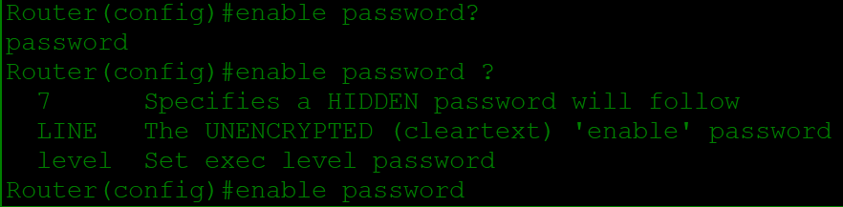
In this picture we could see we used the question mark ( ? ) differently, one with no space and the other one with a space. The first one with no space shows you possible completions of that word. The one with the space and there is a difference in the output, this time it shows all possible options we can enter next in the command.
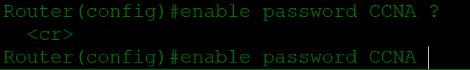
The <cr> indicates that there are no further options. Passwords are case sensitive which means, if you enter a password CCNA and later tried entering ccna it won’t work.
To exit the privileged mode just type exit, and if you type exit in the user mode it will return you to the starting page.
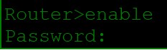
After entering a password and saving it, we tried to access the privileged mode once again and this time it asked me for a password, once you enter the right password it will allow you to use the privileged mode.
Running-config / startup -config
There are two separate configuration files kept on the device at once.
Running-Config = The current, active configuration file on the device, as you enter commands in the CLI, you edit the active configuration.
Startup-Config = The configuration file that will be loaded upon restart of the device.
To see the configuration files, use show running-config command in the CLI to show the current running configuration file.
and also use show startup-config command. After running this command, you may get a message saying “startup-config is not present”, this is because we haven’t saved the running configuration yet. So, every time we restart the device it will load the default configuration not the startup configuration and there is 3 ways to save the running configuration. All 3 of the commands are executed from privileged EXEC mode.
- write
- write memory
- copy running-config startup-config = This one simply saying to copy the running-config file, to the startup-config file.
They all perform the same function.
The command service password-encryption will encrypt all passwords in a mix of letters and numbers, so that they cannot be easily read.
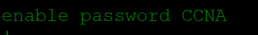
After we type show running-config command, we can see the privileged password in there and this is a security problem if anyone sees it. So, the command service password-encryption, encrypts the password making it a mix of letters and numbers. Example:
We can see now that the password that was CCNA are now numbers and letter, but that doesn’t change the password at all it still CCNA but encrypted so nobody can see it.
You can only the command service password-encryption in the conf t (Configure terminal).
This type of encryption can be cracked easily, but there is a tougher encryption option out there, use the command enable secret (enter password different from the previous one). Example:
It must be different from the previous one, we have used CCNA and now it is Cicso. It replaces the old password which was CCNA with the new one Cicso.
Notice that there are 5 in front of the encrypted password, that just means that it is using MD5 encryption which is better than the service password-encryption.
If you enable service password-encryption:
- current passwords will be encrypted
- future passwords will be encrypted
- the enable secret will not be affected.
If you disable service password-encryption:
- Current passwords will not be encrypted
- Future passwords will not be encrypted
- The enable secret will not be effected.
Modes Review:
- Router> = User EXEC mode
- Router# = Privileged EXEC mode
- Router ( config ) # = Global configuration mode
Commands Review:
- Enable or en = Used to enter privileged mode
- Configure terminal or conf t = Used to enter global configuration mode
- Enable password = Configures a password to protect privileged EXEC mode
- Service password-encryption = encrypts the enable password and other passwords.
- Enable secret = Configures a more secure, enable password which is always-encrypted.
- Run (Privileged exec level command) = executes a privileged EXEC level command from global configuration mode.
- No = which is used to remove a command
- Sh run or Show running-config = Displays the current, active configuration file.
- Show startup-config = Displays the saved configuration file which will be loaded if the device is restarted.
- Write, write memory and copy running-config startup-config = all of them are used to save the configuration
Questions
- What kind of cable is used to connect to a cisco device via the RJ45 console port?
- Rollover Cable
- Crossover Cable
- USB Cable
Answer is A. Rollover Cable
- You type enable to enter a privileged EXEC mode on your cisco router, however the password you enter is not accepted. What could be the problem?
- Service password-encryption is enabled
- Service password-encryption is disabled
- Caps lock on
The answer is C. Caps lock on
- What is the most secure method to protect access to privileged EXEC mode?
- The enable secret command
- The enable password command
- The enable password command, with service password-encryption
The answer is A. The enable secret command
- If both the enable password and the enable secret command are configured, what will happen when you use enable to enter privileged EXEC mode?
- You must enter the enable password, followed by the enable secret
- You must enter the enable password inly
- You must enter the enable secret only
The answer is C. You must enter the enable secret only
- You enter the conf t command to enter global configuration mode. What is the full-length version of the command?
- Configuration time
- Configure Terminal
- Configuration Terminal
The answer is B. Configure Terminal
Ethernet LAN Switching – Part 1
Review:
7 | Application
6 | Presentation
5 | Session
4 | Transport
3 | Network
2 | Data Link
1 | Physical
OSI model – Physical Layer
- Defines Physical characteristics of the medium used to transfer data between devices.
- For example, Voltage levels, maximum transmission distances, physical connectors, cable, specifications, etc.
- Digital bits are converted into electrical (for wired connections) or radio ( for wireless connections) signals.
- All of the information in Interfaces and Cables ( Cables, pin layouts, etc.) is related to the physical layer.
OSI model – Data Link layer
- Provides node-to-node connectivity and data transfer (for example, PC to switch, switch to router, router to router).
- It defines how data is formatted for transmission over physical medium (for example, copper UTP cables).
- It detects and (possibly) corrects physical layer errors.
- It uses layer 2 addressing, separate from layer 3 addressing.
- Switches operate at layer 2
In this lesson we will be talking about Ethernet LAN switching and ethernet involve layer 1, and layer 2 of the OSI model. This lesson is about layer 2.
Ethernet Frame
Here an Ethernet frame encapsulating the packet with header and trailer.
There are 5 fields in the header; first the preamble and SFD (Start frame Delimiter) these are used for synchronization and to allow the device to be prepared to receive the rest of the data in the frame.
Next is the destination, the layer 2 address to which the frame is being sent.
Next is the source the layer 2 address of the device which sent the frame. And the final field in the ethernet header is type it indicates the layer 3 protocol used in the encapsulated packet which is almost always internet protocol or IP version 4 (IPv4) or IP version 6 (IPv6). However, sometimes this is a length field indicating the encapsulated data, depending on the version of the Ethernet.
Now the Ethernet trailer has only one field that is FCS (Frame Check Sequence), it is used by the receiving device to detect any errors that might have occurred in the transmission.
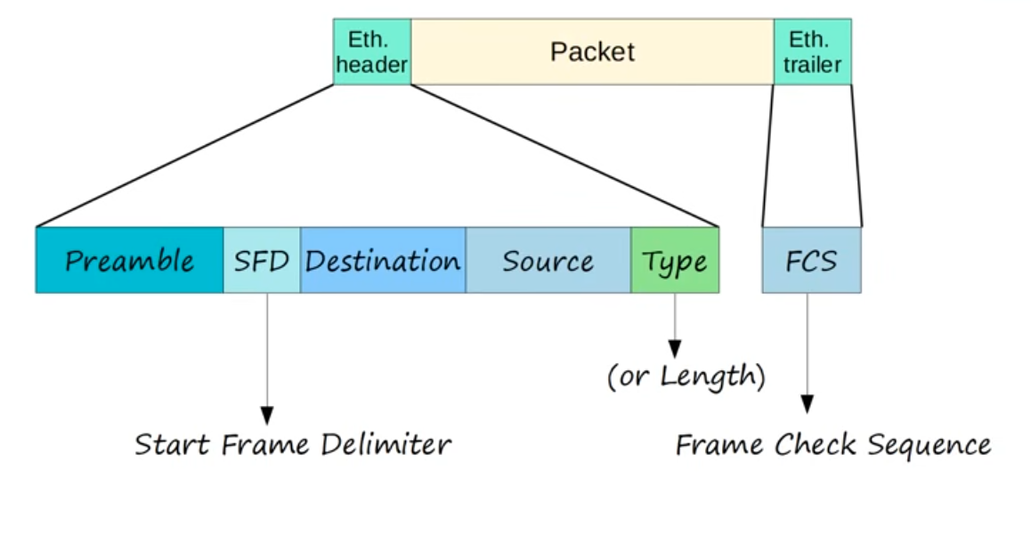
Ethernet Header
Let’s look at the fields in more detail starting with Preamble and SFD.
Preamble | SFD (Start Frame Delimiter)
It is 7 bytes longs (56 bits). | Its length is 1 byte (8 bits)
It is a serious of alternating 1’s and 0’. | It indicated the end of the end of the preamble, and the beginning of the rest of the frame.
It allows devices to synchronize their receiver clocks to make sure they are ready to receive the rest of frame and the data inside.

Destination & Source
They indicate the devices sending and receiving the frame.
The addresses that are used in the ethernet are the destination and source MAC addresses.
MAC = (Media Access Control)
The MAC address is a 6 byte or (48 bits) address of the physical device. This is separate from a logical address like an IP address.
The MAC address is actually assigned to the device when it is made

Type or Length
Its 2 bytes or (16 bits) in length, it can be used to represent either the type of the encapsulated packet or the length encapsulated packet
What does that mean? If the value in this field is 1500 or less that means it is indicating the length of the encapsulated packet in byes.
How ever a value of 1536 or greater in this field, indicated that the TYPE of the encapsulated packet which is usually Internet Protocol Version 4 (IPv4) or Internet Protocol Version 6 (IPv6), and the length is determined via other methods

Those are all the fields in the Ethernet header and the length of each fields are:
- Preamble = 7 bytes long
- SFD = 1 byte
- Destination = 6 bytes
- Source = 6 bytes | Both Destination and Source are 6 bytes because they are MAC addresses.
- Type or Length = 2 bytes
Ethernet Trailer
The only field of the Ethernet trailer is FCS (Frame Check Sequence).
- It is 4 bytes (32 bits) in length.
- It is purpose is to detect corrupted data by running a CRC algorithm over the received data.
- CRC stands for Cyclic Redundancy Check. Cyclic refers to something called cyclic codes, redundancy refers to fact these 4 bytes at the end of the message, enlarge the message without adding any new information so they are redundant. And check refers to the fact that it checks, or verifies data for errors.
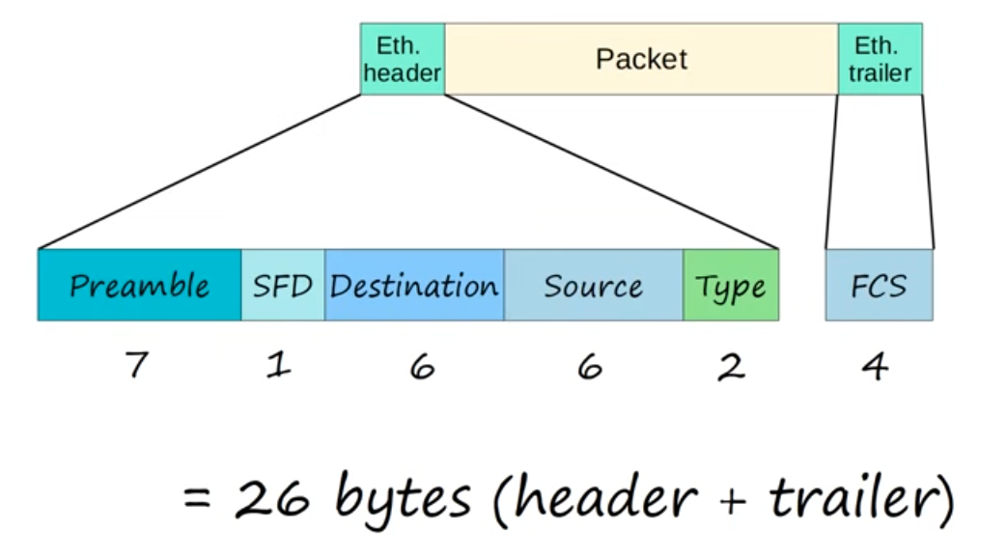
MAC Address
A mac address is a 6 byte (48 bits) physical address assigned to the device when it is made. It is also known as Burned-in Address (BIA), this is because the address is burned-in to the device is it is made.
The MAC address is globally unique, no two devices in the world should have the same MAC address. There are MAC addresses know as Locally unique MAC addresses which don’t have to be globally unique throughout the world. However, almost all cases MAC addresses are globally unique.
The first 3 bytes of the MAC address are the OUI which stands for (Organizationally Unique Identifier) and it is assigned to the company making the device.
The last 3 bytes, the second half of the address, are unique to the device itself.
MAC addresses, are written as series of 12 Hexadecimal characters.
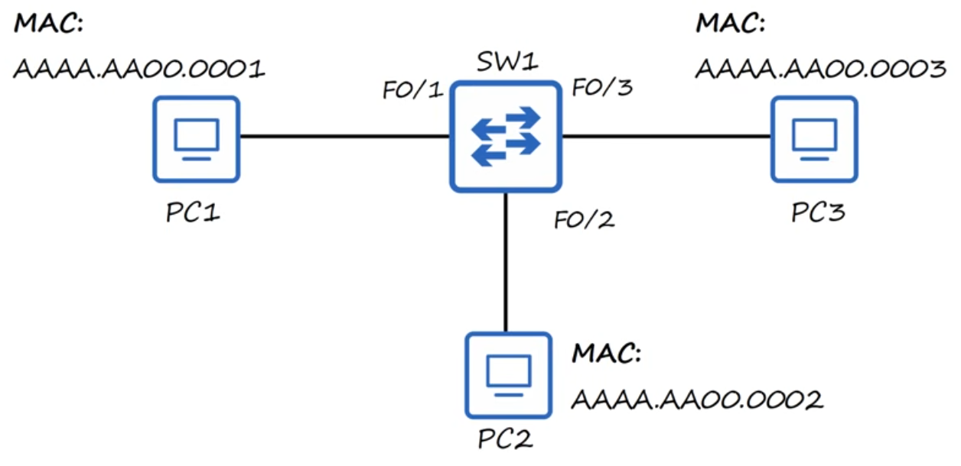
Here a simple network, 3 PCs connected to a switch. Each MAC address is a 12 hexadecimal digits separated by periods. The OUI which is (Organizationally Unique Identifier) which Is the first half of the MAC address is AAAA for each device, now we know all those PCs are from the same maker. The second half of the MAC address of each device is different for each PC, which the second half identifies the device itself. Now let’s say PC1 wants to send some data to PC2, this frame is called Unicast frame (A frame designed for a single target “PC2 in this case” ).
PC1 sends the frame through it is network interface card which is connected to switch1, and switch1 receives the frame. After switch1 receives the frame, it looks at the source MAC address field of the frame and then uses that information to learn where PC1 is.
Look at the picture below:
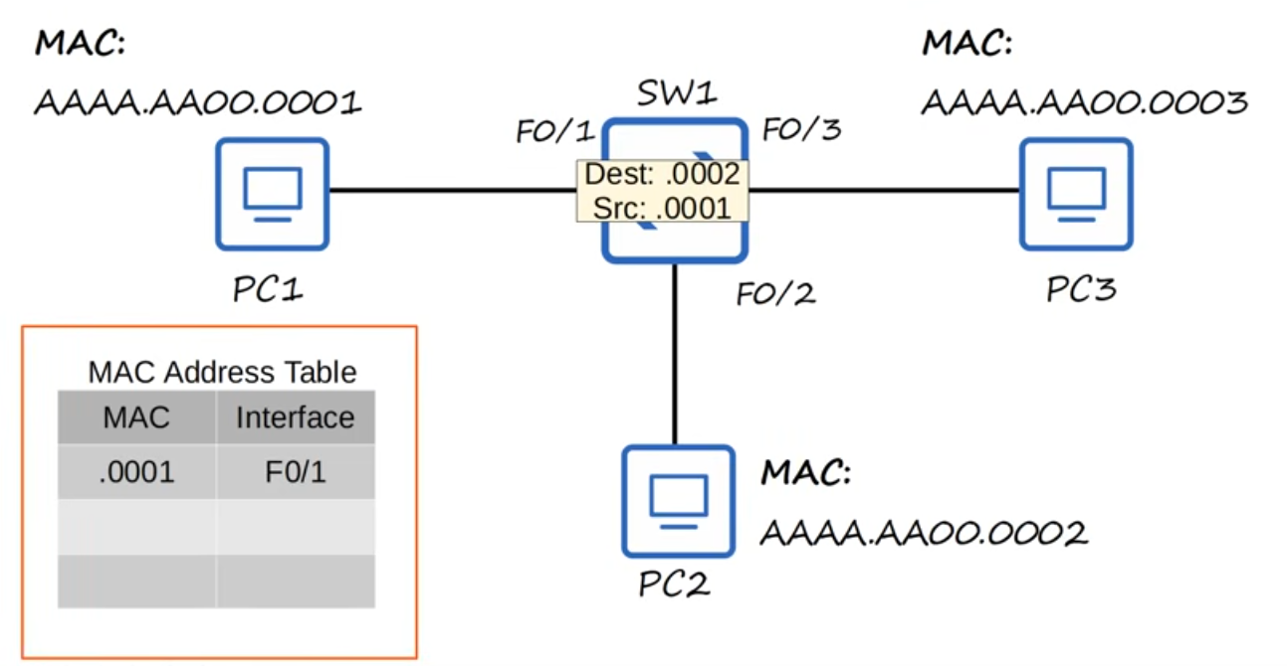
As you can see at bottom left of MAC address Table, it adds the MAC address AAAA.AA00.0001 to it is MAC address table, and it associates that MAC address with its F0/1 interface. This is known as Dynamically leaned MAC address or Dynamic MAC address, because it wasn’t manually configured in the switch, the switch learned it itself. Every switch will keep a MAC address Table like in the picture and they fill the MAC address table dynamically by looking at the source MAC address of the frame it receives. Since switch1 received a frame from source MAC address AAAA.AA00.0001 on its interface F0/1, it knows it can reach that MAC address on that interface, and adds it to the MAC address table. There is one problem, the destination of the frame is AAAA.AA00.0002 but switch1 doesn’t know where that is and this is called Unknown Unicast frame, a frame for which the switch doesn’t have an entry in its MAC address table. Because the switch doesn’t know how to reach its destination, it has only one option and that is to flood the frame which means to flood the frame out of its all its interfaces except the one it received the packet on. On our case the frame will be flooded through F0/2 and F0/3 but not F0/1 because it received the data in that interface. What happens next? For PC3 it will ignore the packet because the destination packet doesn’t match its MAC address, it simply drops the packet. However, PC2 receives the packet and then process it normally up the OSI stack, however, unless PC2 sends a reply or some sort it stops there, switch1 never receives a packet from PC2 so it can’t learn PC2’s MAC address and use it to populate the MAC address table.
Let’s say PC1 sends another frame to PC2 again, once again it received by switch1 and it already knows PC1’s MAC address so it doesn’t have to add it to the MAC address table again. However, still it doesn’t know where PC2 is, so once again it floods the frame and of course PC3 drops the frame instantly because it doesn’t match its MAC address and PC2 receives it and process it normally.
Now, let’s say PC2 want to send some data to PC1 maybe a reply to what PC1 sent to PC2. PC2 sends the frame out of its network interface which is F0/2 and switch1 receives it. Swich1 looks at the source MAC address of the frame, and then adds it to its MAC address table associating it with F0/2 interface. This time however it doesn’t flood the frame, this is known as Known Unicast Frame because the destination is already in its MAC address table. Whereas Unknown Unicast frames are flooded, Known Unicast frames will simply forward it to the destination which will go straight to PC1.
On cisco switches, Dynamic MAC addresses are removed from the MAC address table after 5 minutes of inactivity. So, if PC1 didn’t send any traffic for over 5 minutes, switch1 will remove the MAC address to clean out the MAC address table.
Questions
- Which field of an Ethernet frame provides receiver clock synchronization?
- Preamble
- SFD (Start frame Delimiter)
- Type
- FCS
Answer is: A. Preamble
- How long is the physical address of a network device?
- 32 Bytes
- 32 Bits
- 48 Bytes
- 48 Bits
Answer is: D. 48 Bits
- What is OUI of this MAC address E8BA.7011.2874?
- E8BA
- E8BA.70
- 7011
- E8BA.7011
Answer is: B. E8BA.70
- Which field of an Ethernet frame does a switch use to populate its MAC address table?
- Preamble
- Length
- Source MAC address
- Destination MAC address
Answer is: C. Source MAC address
- What kind of frame does a switch flood out of all interfaces except the one it was received on?
- Unknown Unicast
- Known Unicast
- Allcast
Answer is: A. Unknown Unicast
Ethernet LAN Switching – Part 2
ARP
ARP stands for Address Resolution Protocol; it is used to discover the layer 2 address (MAC address) of a known Layer 3 address (IP address).
The ARP process consists of two messages: the ARP request; sent by the device that wants to know the MAC address of the other device.
ARP Reply; which is sent to inform the requesting device of the MAC address. In our example, PC1 would send the ARP request and PC3 would send the ARO reply.
The ARP request is sent as a broadcast ethernet frame. Broadcast means it is sent to all hosts on the network. Because the layer 2 address of the destination host is unknown, it broadcasts the request and waits for a reply from the correct device.
The ARP reply is unicast, we learned that unicast is sent to only one host in this case it is the host that sent the ARP request.
Let’s take a look on how this works on our network:
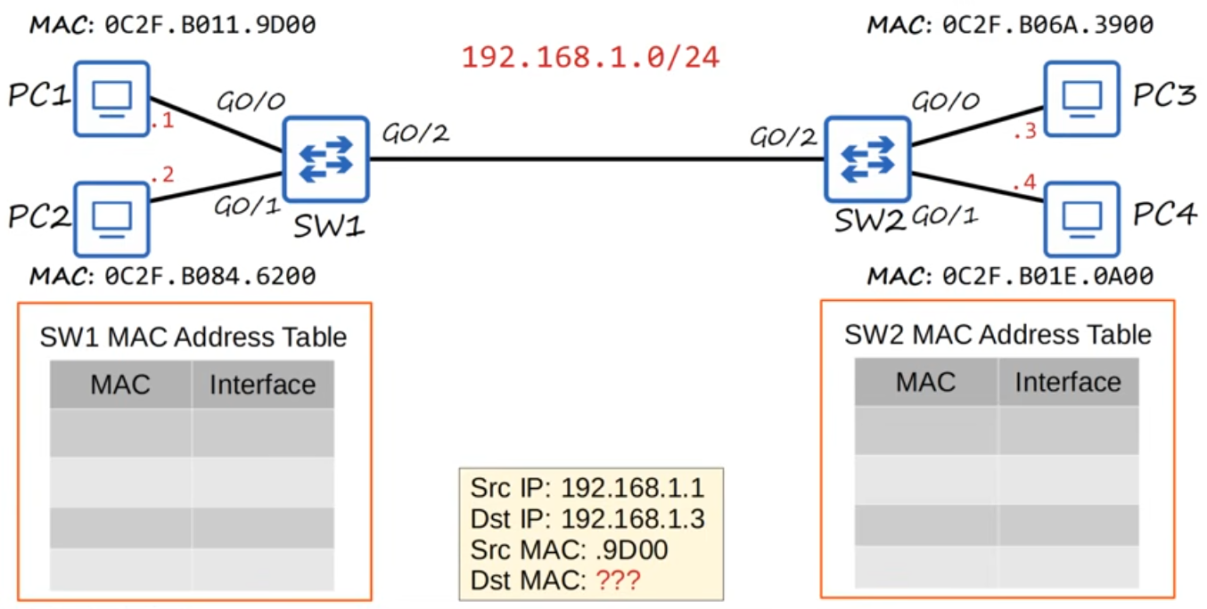
At the bottom of the picture is the original frame that PC1 wants to send to PC3, but first it has to send this kind of frame: look at the picture below.
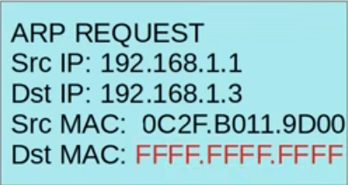
This is an ARP request frame; the source and the destination IP addresses as well as the source MAC address are the same. However, look at the destination MAC address; FFFF.FFFF.FFFF is the broadcast MAC address this is the destination MAC address used when a device wants to send ethernet frame to all other devices on the local network.
So, PC1 has prepared ARP request to be sent, it sends the frame out of its network interface and it’s received by switch1, switch1 then adds PC1 MAC address to its MAC address table. When a MAC address is learned in this way, what it is called? It’s called dynamic MAC address.
Since the destination MAC address is all F’s, switch1 broadcasts the frame out of all its interfaces except the one it received the request on. This is pretty much like what switch does with an unknown unicast frame. PC2 will ignore the request because the destination IP address doesn’t match its IP address. Switch2 receives it and adds the source MAC address to its MAC address table, since the destination MAC address is the broadcast MAC address, switch2 also send the frame out of its all interfaces except the one the frame was received on. PC4 will ignore the frame jut like PC2, and PC3 will recognize that the destination IP address does match its own IP address so it doesn’t ignore the ARP request. What it does, is send the other ARP message we mentioned earlier which is ARP reply. Look at the picture below for ARP reply Example:
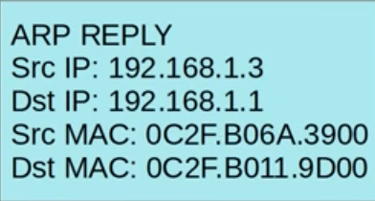
The source IP is PC3’s IP, and the destination IP is PC1’s IP. The Source MAC is PC3’s MAC address, and the destination address is the PC1’s IP address. Although the ARP request message was a broadcast message, because PC1 MAC address was used as the source MAC address of the ARP message, PC3 now knows PC1’s MAC address so it can send the ARP reply directly to PC1 without having to broadcast the frame.
PC3 send the ARP reply out of its interface and it’s received by Switch2, switch2 learns PC3’s MAC address and adds it to its MAC address table. Since this is a unicast frame and switch2 has already has an entry for the destination MAC address in its MAC address table, what kind of frame is this? And what does switch2 do with this? It’s a known unicast frame and switch2 will simply forwarded out of the interface and it will not flood it like unknown unicast frame or broadcast frame. Now switch1 receives the reply and forwards it to PC1 because it already knows the destination source of PC1.
ARP Table
Use arp -a in CMD on Windows to view ARP table.
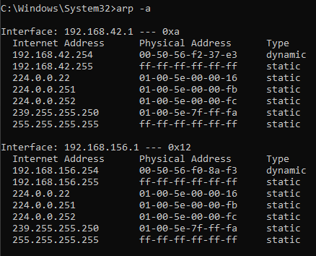
The internet address column displays IP addresses (layer 3 address).
The physical address column displays the MAC address that correspond to the IP addresses (layer 2 address).
If the type column didn’t display static; it means that it is the default entry it wasn’t actually learned by sending an ARP request, however, if the type column displays dynamic, that means the entry was learned by sending an ARP request and receiving an ARP reply.
Ping
Ping it’s a network utility that is used to test reachability. For example, to test two computers can reach each other.
It measures around-trip time. For example, the time from PC1 to PC2 then back to PC1.
Much like ARP, ping uses two messages ICMP Echo Request and ICMP Echo Reply this is similar to ARP request and ARP reply. However, the PC1 broadcast the ICMP Echo Request it’s sent to specific host, so it has to know the MAC address of the destination host, which is why ARP must be used first.
The command to use ping is: Ping followed by the IP address you want to ping to. For example:
Ping 192.168.1.3 for PC3.
Let’s look at the ping process:
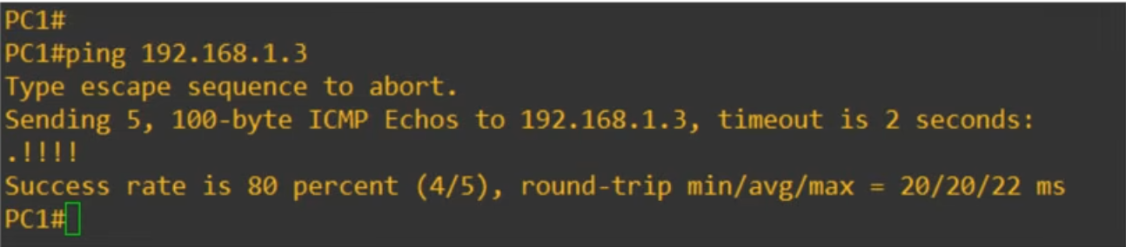
We used the command ping 192.168.1.3 to send an ICMP Echo Request to PC3. Take a look at the message that says: Sending 5, 100-byte ICM Echos to 192.168.1.3, timeout is 2 seconds: .!!!!
By default, a ping is cisco IOS sends 5 ICMP Echo Requests and then you should get a 5 ICMP Echo Replies back and the default size of each ping is 100-bytes. The period ( . ) indicates a failed ping, and the exclamation points ( ! ) indicate a successful ping.
As it says: Success rate is 80 percent (4/5), round-trip min/avg/max = 20/20/22 ms.
It shows that 4 out of 5 pings was successful and the round-trip of minimum, average and maximum rates are 20 for minimum, 20 for average and 22 for maximum.
Why did that first ping failed? Well, that is because of ARP. PC1 didn’t know the destination address so it had to use ARP and, in that time, the first ping failed. After PC1 learned PC3’s MAC address however, the ping succeeded.
The command for windows, Linux and MacOS was arp -a. however, in cisco IOS, it’s show arp from privileged EXEC mode.

Clearing The MAC Address Table
Earlier in the lesson we mentioned that these dynamic MAC addresses are removed from the MAC address table after 5 minutes this is known as Aging if the switch doesn’t get any traffic from that MAC address for 5 minutes, it will remove the entry from the MAC address table. However, you can also manually remove the MAC addresses from the table.
Look at the picture below:
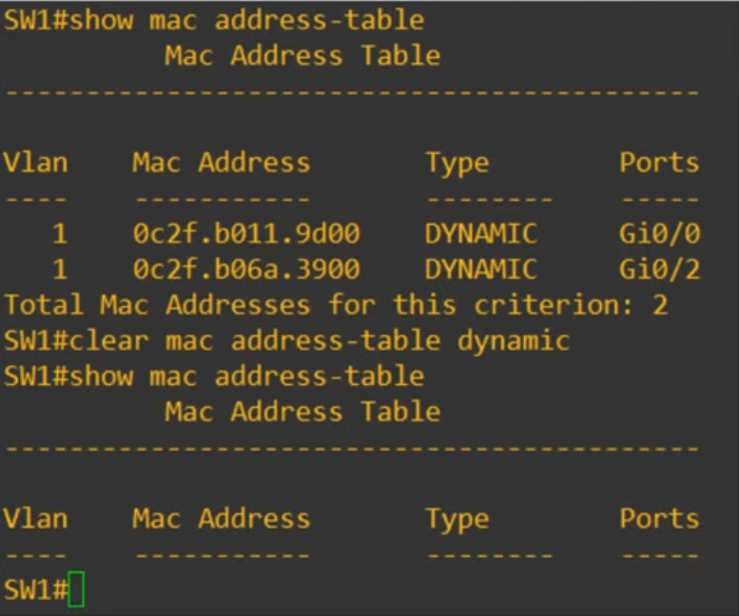
We can see that we use the command: “show mac address-table” and you can see the entries for PC1 and PC3. Then we used the command: “clear mac address-table dynamic” and as you can see at the bottom of the pic all of the dynamic MAC addresses have been removed.
Remember this commands: clear mac address-table dynamic.
If you don’t want to clear all of the MAC addresses from the table, you can add some additional options to the command. Look at the picture below:
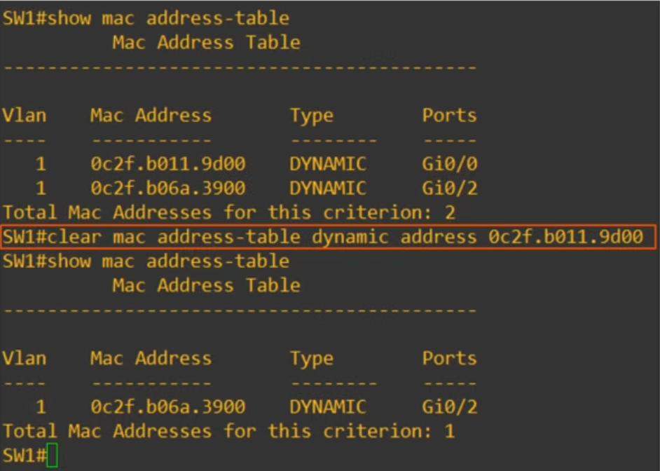

We use the command show mac address-table once again and this time we used a different command: “clear mac address-table dynamic address 0c2f.b011.9d00” we used PC1’s MAC address and removed it from the table and again we used the command show mac address-table to see if we removed PC1 from the MAC address table and it’s not in the table.
Remember this command: clear mac address-table dynamic address “mac-address of the desired device”.
There is a third and last method to clear the MAC address table. The command is: “clear mac address-table dynamic interface Gi0/0”.
Look at the picture below:
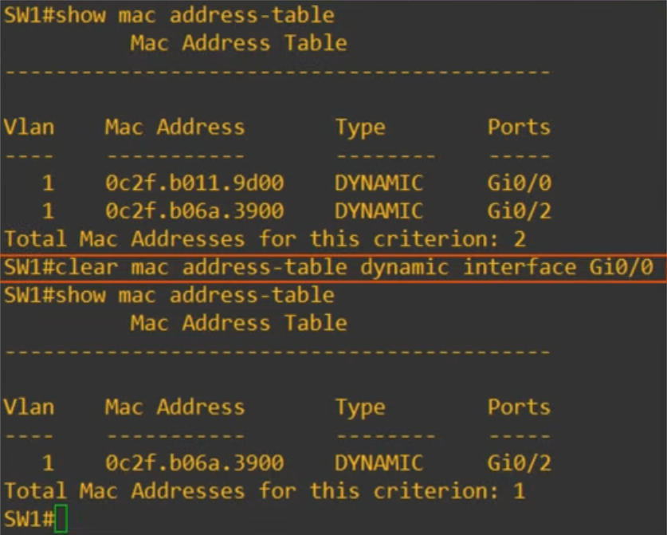
This clears all MAC address table entries for specific interface. Once again, PC1 is removed because it’s connected to Gi0/0 interface.
Remember this command: clear mac address-table dynamic interface “interface-id”.
Topics Covered
- Ethernet Frame Payload minimum size
- ARP (Address Resolution Protocol) it’s used to learn the MAC address of a device for which it already knows the IP address. It uses two messages: an ARP request which is broadcast to all devices on the local network and an ARP reply which is sent to the device which sent the request.
- ARP Table on a windows device and a cisco IOS device.
- Ping which is used to test the reachability in a network, it also uses two messages: ICMP Echo Request and ICMP Echo Reply
- MAC address Table on a Cisco Switch including how to clear it in a few ways.

Questions
- You send a 36-byte ping to another computer and perform a packet capture to analyze the network traffic. You notice a long series of bytes of 00000000 at the end of the Ethernet payload. How can you explain these zeros?
- Pings are a series of zeroes
- They are padding bytes
- They are the Ethernet FCS
Answer is B. They are padding bytes
Explanation: The ping you sent was 36 bytes, but the minimum Ethernet payload size is 46 bytes. A series of padding bytes must be added to meet the minimum payload size.
- Which of these messages is sent to all hosts on the local network?
- ARP Request
- ARP Reply
- ICMP Echo Request
- ICMP Echo Reply
Answer is A. ARP Request
- Which fields is the present in the output of the “show mac address-table” command on a Cisco Switch?
- MAC address, Ports
- VLAN, MAC address, Ports
- VLAN, MAC address, Type, ports
- Internet Address, Physical Address, Type
Answer is C. VLAN, MAC address, Type, Ports
- Which type of frames does a switch send out of all interfaces, except the one the frame was received on?
- Broadcast and Unknown Unicast
- Broadcast and known Unicast
- Known Unicast and Unknown Unicast
- Broadcast, unknown unicast, known unicast
Answer is A. Broadcast and Unknown Unicast
- Which command Is used on a Cisco Switch to clear all dynamic MAC addresses on a specific interface from the MAC address Table?
- Clear mac address-table interface “interface-id”
- Clear mac-address-table dynamic interface “interface-id”
- Clear mac-address table dynamic interface “interface-id”
- Clear mac address-table dynamic interface “interface-id”
Answer is D. Clear mac address-table dynamic interface “interface-id”
Analyzing Ethernet Switching Day 6 Lab

